<http://jira.pentaho.com/browse/DOC-3127>

# Create process documentation for Jira bug creation

# [JIRA Bug Creation](http://iwiki.pentaho.com/display/DOC/Jira+Projects)

<http://iwiki.pentaho.com/display/DOC/JIRA>

When an error is found in our documentation a Bug case should be created in JIRA so that actions can be taken by the Documentation Team to investigate and correct the issue.

**How to Create a Bug Case in JIRA**

Before entering a new JIRA case, perform a Quick Search using keywords that describe the issue to verify that the case does not currently exist. If the case does exist, then add comments (if needed) and return the case to the Backlog.

Perform the steps below to create a Bug case in JIRA:

1. Log in to JIRA.
2. Press the **Create Issue** button on the Menu bar. The **Create Issue** window opens.

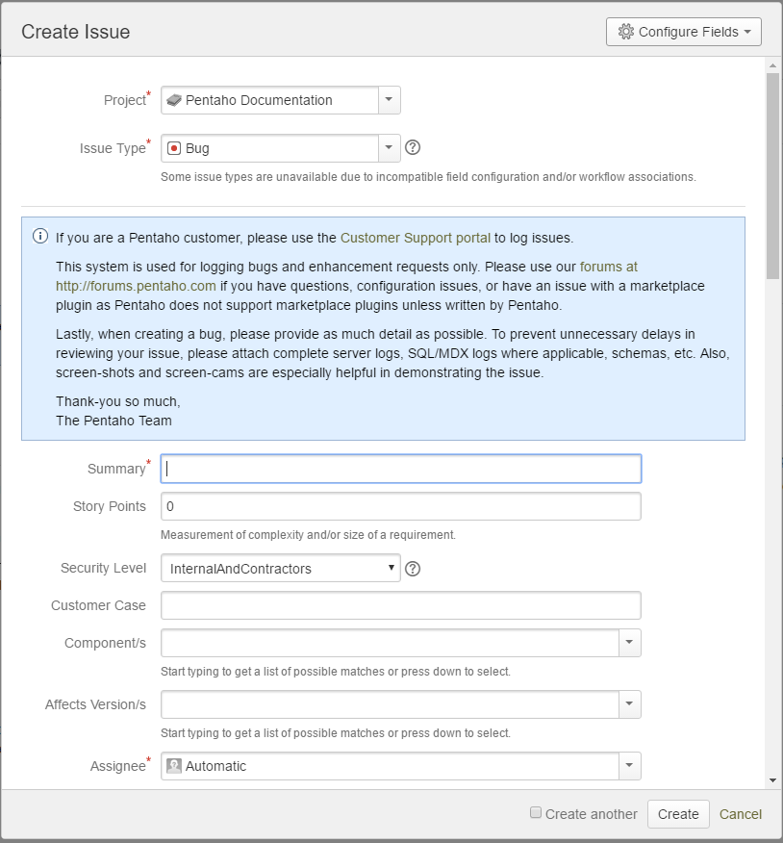

1. Set the **Project** to **Pentaho Documentation**, and the **Issue Type** to **Bug**.
2. Enter a succinct description of the issue in the **Summary** field.
3. Set the **Sprint Team** name to **Obi-Wan Kenobi**.
4. Describe how to recreate the issue in the **Steps to Reproduce** field.
5. Describe the issue in the **Description** field. Provide as much detail as possible regarding the use case and functionality. Add URL locations and the specific MindTouch pages affected, and when applicable attach logs and screen or video captures to help demonstrate the issue.
6. Set the **Defect Type** field to **Documentation**.
7. Click the **Create** button.

Upon completion of these steps, the Bug case will be created and automatically moved to Triage for evaluation.